**Wind energy conversion :**

Wind energy is energy from moving air, caused by temperature (and therefore pressure) differences in the atmosphere. Irradiance from the sun heats up the air, forcing the air to rise. Conversely, where temperatures fall, a low pressure zone develops. Winds (i.e. air flows) balance out the differences. Hence, wind energy is solar energy converted into kinetic energy of moving air. Wind Energy Converters (WECs) - or short: wind turbines - capture the air flow by converting it into a rotational movement, which subsequently drives a conventional generator for electricity. Wind energy has been used for centuries to pump water and grinding. The industrial breakthrough for the generation of electricity, came in the 1980s. Today, wind energy is the most mature of the renewable energy technologies apart from hydro. In 2010, the global installation might reach 200GW, up 5GW in 1995 - that equates to an annual growth rate of 27%.

**Basic Principles of Wind Energy Conversion**

**2.1 The Nature of Wind**

* Wind is caused by the sun heating the Earth unevenly, which creates air movement.
* Warm air rises and cooler, denser air rushes in, causing wind.
* Factors like terrain, clouds, and the sun's position affect wind patterns.
* Coastal areas tend to have strong onshore winds during the day and offshore winds at night.
* Winds are more consistent and stronger over water with less obstruction.

**2.2 The Power in Wind**

* Wind has energy because it's moving.
* Devices like wind turbines can capture some of this energy.
* The power a wind turbine generates depends on three things: wind speed, the area the rotor covers, and the efficiency of the whole system.
* No device can capture all the wind's energy; the best efficiency is around 60%.
* Real-world wind turbines typically achieve about 35% efficiency.

**2.3 Calculation of Power in the Wind**

* Wind power is calculated using kinetic energy, which depends on the mass and velocity of moving air.

Kinetic Energy of particle = ½ mv2

Where M : Mass of particle (kg) V : Velocity of particle (m/s)

* The amount of air passing through a wind turbine's blades is related to its area and air density.

**2.4 Power Coefficient**

* The power coefficient tells us how much of the wind's power a rotor can capture.
* It's the ratio of the power generated by the rotor to the total power available in the wind.
* The maximum theoretical power coefficient is about 0.59 (or 59%).

**2.5 Instantaneous Wind Power**

* Wind speed isn't constant; it varies over time.
* To find the average power, you need to cube the wind speeds and take the time average.
* This helps us understand how much power is available in the wind.

**2.6 Expression for Maximum Power in Wind**

* The thickness of a wind turbine's blades affects its performance.
* A horizontal-axis wind turbine with an ideal thickness aims for the best balance between capturing power and avoiding damage from high wind speeds.

**2.7 Condition for Maximum Wind Power**

* To get the most power from a wind turbine, you need to find the right exit velocity (Ve,opt).
* This maximum theoretical efficiency is called the Betz coefficient, and it's about 59%.

In simple terms, wind energy relies on the movement of air caused by the sun's heat. Wind turbines capture this moving air to generate power, but they can't capture all of it. The efficiency of capturing wind energy depends on various factors, like wind speed and the design of the turbine. Scientists have calculated that the maximum efficiency is around 59%.

**Factors influencing wind:**

**Wind is a valuable source of sustainable energy, but there are several factors that influence it. Here's a simple explanation:**

**1. **Location:** Wind energy is more abundant in certain places. Coastal areas and open fields tend to have more consistent and stronger winds, making them ideal for wind farms.**

**2. **Wind Speed:** Faster winds generate more energy. Wind turbines need a minimum wind speed to start turning their blades and produce electricity effectively.**

**3. **Wind Direction:** Wind doesn't always blow in the same direction. Wind turbines are designed to face into the wind, so their orientation matters for efficiency.**

**4. **Obstacles:** Buildings, trees, and hills can block or disrupt the wind, reducing its energy potential. Wind turbines are usually placed in areas with fewer obstructions.**

**5. **Altitude:** Wind speed generally increases with height above the ground. Taller wind turbines can access stronger and more consistent winds.**

**6. **Weather Patterns:** Seasonal changes and weather patterns can affect wind availability. Some areas have windier seasons, while others may experience calmer periods.**

**7. **Technological Advances:** Ongoing improvements in wind turbine technology make it possible to harness energy from lower wind speeds and in a wider range of locations.**

**In summary, the availability and reliability of wind energy depend on where you are, how fast and consistent the wind is, and the technology used to capture it. These factors are crucial in harnessing wind power for sustainable energy.**

**Wind data and energy estimation- wind speed monitoring:**

When thinking of installing a small wind turbine at your home or farm, there are a few things to consider, but probably the most important can be summarised in the following key points:

**\*\*6.1 Height\*\***

**- Taller wind turbine towers are better because they encounter fewer obstacles and experience less turbulent wind, resulting in higher wind speeds.**

**\*\*6.2 Location\*\***

**- Where you place your wind turbine is crucial. Even if you're in a windy area, the spot you choose could have obstacles like trees, buildings, or towns nearby that disrupt the wind, reducing its speed.**

**\*\*6.3 Size of the Wind Turbine\*\***

**- Bigger wind turbines with larger rotor blades capture more wind, leading to more energy generation. This is similar to how larger sails on a ship capture more wind.**

**\*\*6.4 Planning Your Wind Speed Monitoring\*\***

**- Before setting up a wind turbine, it's important to monitor the wind speed at your location for a period of time, preferably using a professional wind logger.**

**- Key things to track include average, maximum, and standard deviation wind speeds (to understand turbulence).**

**- You also need to know the prevailing wind direction and speed.**

**- Professionals often use MET or wind masts with sensors at different heights to get a comprehensive view of wind conditions.**

**- Measuring wind shear (changes in wind speed at different heights) helps in selecting the right wind turbine.**

**\*\*6.5 Equipment\*\***

**- The equipment you need includes anemometers (wind speed sensors), a wind vane (for wind direction), and a wind logger or monitor.**

**- Anemometers should be accurate and calibrated.**

**- The wind logger should store historical data and record wind speed, direction, temperature, pressure, and humidity.**

**- For long-term monitoring, it's best to retrieve data remotely, and you can use solar power to keep the monitor running.**

**In simple terms, when considering a small wind turbine, you need to think about its height, where you place it, and its size. The height should be as tall as possible for better wind. The location should be free from obstructions. Bigger turbines capture more wind. Before installing, monitor the wind using the right equipment and track important wind data. Using professional tools and proper calibration is crucial for accurate results.**

**Site selection:**

**\*\*8.1 High Annual Average Wind Speed:\*\***

**- More wind speed means more power from the wind turbines.**

**- Sites with consistently high wind speeds are ideal.**

**- It's best to look for places where the wind is strong on average.**

**\*\*8.2 Availability of Anemometry Data:\*\***

**- Anemometry data, which measures wind speeds, is crucial.**

**- It should be collected at the exact location where you plan to install wind turbines.**

**- Having this data is important before making any decisions.**

**\*\*8.3 Availability of Wind V(t) Curve:\*\***

**- The wind V(t) curve shows how the wind speed changes over time.**

**- It's essential for predicting the performance of wind turbines and the electricity they generate.**

**- A reliable V(t) curve is vital for knowing when the wind turbines will start turning and when they won't produce power.**

**\*\*8.4 Wind Structure at the Site:\*\***

**- Wind is not always smooth; it can be turbulent, gusty, and change quickly.**

**- This is known as the "structure of the wind."**

**- Ideal sites have steady, constant winds, but many sites have less ideal wind conditions.**

**\*\*8.5 Altitude of the Site:\*\***

**- Higher altitudes can mean higher wind speeds and more power.**

**- Altitude affects air density, which influences power generation.**

**\*\*8.6 Terrain and Aerodynamics:\*\***

**- The landscape matters. Hills, mountains, and the shape of the land can affect wind speed.**

**- Wind direction may not always be horizontal, so wind turbines might need to adjust to the actual wind flow.**

**\*\*8.7 Local Ecology:\*\***

**- The ground conditions matter. Rocky surfaces may reduce costs, while vegetation can increase the need for taller wind turbine structures.**

**\*\*8.8 Distance to Roads or Railways:\*\***

**- Proximity to transportation is crucial for moving heavy machinery and materials to the wind turbine site.**

**\*\*8.9 Nearness to Local Users:\*\***

**- Being close to the places where the electricity will be used reduces the cost and energy loss in long transmission lines.**

**\*\*8.10 Nature of the Ground:\*\***

**- The ground should be stable, not prone to erosion, and suitable for building strong foundations for the wind turbines.**

**\*\*8.11 Favorable Land Cost:\*\***

**- Affordable land prices contribute to the overall cost-effectiveness of the wind energy project.**

**\*\*8.12 Other Conditions:\*\***

**- Factors like icing, salt spray, blowing dust, or environmental issues should not negatively impact the wind turbine's blades or machinery.**

**In simple terms, when choosing a location for wind turbines, you want consistent high wind speeds. You need data about wind speeds at that exact location and a wind speed curve. Terrain, altitude, and local ecology matter, as well as the proximity to roads and users. The ground should be stable and erosion-free. Finally, consider the overall cost, and be aware of any environmental challenges.**

**Betz limit**

* The Betz limit is also known as the "Betz coefficient" and is expressed as 59.3% (0.593) of the kinetic energy in the wind that can be converted into mechanical energy.
* The Betz limit is based on the conservation of mass and energy principles, which means there must be a balance between the kinetic energy of the incoming wind and the kinetic energy of the wind leaving the wind turbine.
* Wind turbines have different components that affect their efficiency, including the rotor blades, generator, and gearbox. These components introduce losses that make it challenging to reach the Betz limit.
* The Betz limit helps engineers and designers set realistic expectations for wind turbine performance and design more efficient turbines.
* While most wind turbines do not reach the Betz limit, improvements in design, materials, and technology continue to increase their efficiency, helping us harness more wind energy.
* Wind turbine efficiency is also influenced by factors such as wind speed, air density, and the size and design of the turbine rotor.
* Understanding the Betz limit is essential for optimizing the design and placement of wind turbines to maximize their energy capture and electricity generation.
* Wind energy is a clean and sustainable source of power, and improving wind turbine efficiency is crucial for expanding the use of wind energy in the future.

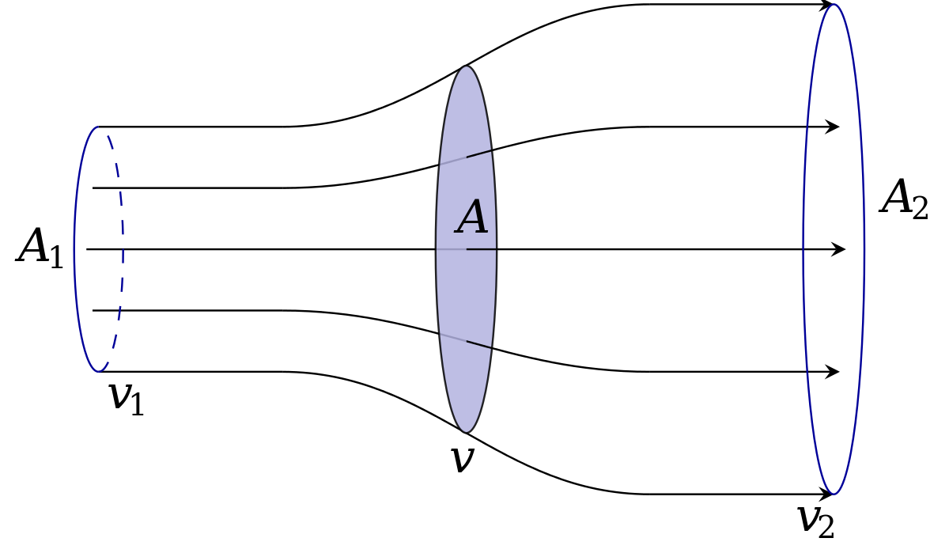

**Components of a wind energy conversion system:**

A Wind Energy Conversion System (WECS) consists of several key components that work together to harness wind energy and convert it into electricity. Here are the main components:

* **Wind Turbine:** The wind turbine is the most visible part of the system and includes large rotor blades. These blades capture the kinetic energy of the wind. The design and size of the turbine blades significantly impact energy capture and efficiency.
* **Nacelle:** The nacelle is a housing located at the top of the tower, just behind the rotor hub. Inside the nacelle, you'll find critical components such as the generator, gearbox (if present), and other electrical elements. It serves as the control center for the turbine's operation.
* **Tower:** The tower provides the structural support for the wind turbine. It elevates the turbine to an optimal height to access higher and more consistent winds. Taller towers are essential for maximizing energy generation.
* **Generator:** The generator is a fundamental component that converts the mechanical energy transmitted from the rotor into electrical energy. Two common types are synchronous generators and permanent magnet generators. The generator output determines the electrical power produced.
* **Yaw System:** The yaw system enables the entire wind turbine to rotate horizontally, ensuring the rotor always faces into the wind. It's vital for maximizing energy capture, as it allows the turbine to adjust its orientation as wind direction changes.
* **Controller and Control System:** These components monitor wind conditions and turbine performance. They make real-time adjustments to the pitch and yaw systems to optimize energy capture and ensure safe operation. The control system plays a crucial role in maximizing efficiency.
* **Foundation:** The foundation anchors the wind turbine securely to the ground and provides stability. The type of foundation, whether it's concrete, steel, or another material, depends on the location and soil conditions. A solid foundation is essential for the safe and effective operation of the turbine.
* **Anemometer:** An anemometer is a device that measures wind speed. This data is crucial for the control system, enabling it to make real-time adjustments to the turbine's settings based on the wind's speed.
* **Wind Vane:** A wind vane indicates the wind's direction. This information helps the yaw system adjust the turbine's orientation to ensure that it always faces into the wind, optimizing energy capture.

**Torque on wind:**

**When we talk about wind turbines with propeller-type blades, there are two main forces at play on these blades:**

**1. **Circumferential Force (Torque):** This force acts in the direction of the wind turbine's rotation and is responsible for providing the twisting force, known as torque. Torque is what makes the rotor blades turn, and it's crucial for generating power from the wind.**

**2. **Axial Force:** This force acts in the direction of the oncoming wind and provides an axial thrust. This axial thrust is like a push from the wind and needs to be managed through proper mechanical design to ensure the wind turbine operates effectively.**

**Now, to calculate the Circumferential Force, or Torque (T), we use the following formula:**

**T = (1/2) * ρ * A * V^2 * C_p**

**Where:**

**- T represents the torque (the twisting force).**

**- ρ is the air density.**

**- A is the area swept by the rotor blades.**

**- V is the wind speed.**

**- C_p is the power coefficient, which depends on the wind turbine's design and efficiency.**

**In simple terms, this formula helps us figure out the twisting force (torque) that the wind turbine blades can generate. It takes into account factors like the air density, the area covered by the rotor blades, the wind speed, and the efficiency of the wind turbine's design. Understanding this torque is important for harnessing wind energy effectively.**

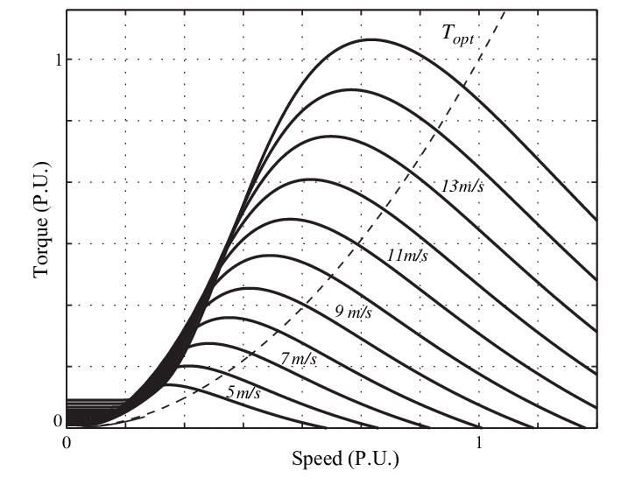

**Wind thrust calculations Repowering concept:**

**Let's break down the concept of wind thrust calculations and the idea of repowering wind turbines into simple points:**

**\*\*Wind Thrust Calculations:\*\***

**1. **Wind Thrust:** Wind turbines experience a force known as wind thrust. This is the push from the oncoming wind that the turbine blades need to counter to remain stable and generate power.**

**2. **Calculation:** Wind thrust is calculated by considering factors like the size and shape of the blades, the wind speed, and the angle of attack of the blades.**

**3. **Importance:** Understanding wind thrust is crucial for designing and maintaining wind turbines, ensuring they can withstand varying wind conditions.**

**\*\*Repowering Concept:\*\***

**1. **Repowering:** Repowering is the process of upgrading or replacing components of an existing wind turbine to improve its performance and efficiency.**

**2. **Reasons for Repowering:** Repowering may be done to increase the energy output, extend the turbine's lifespan, or adapt to new technology and regulations.**

**3. **Upgrades:** Repowering may involve upgrading the rotor blades, the generator, or other components to harness more energy from the wind.**

**4. **Environmental Benefits:** Repowering older turbines with newer, more efficient technology can have environmental benefits by generating more energy with fewer turbines.**

**5. **Economic Considerations:** Repowering can be a cost-effective way to improve energy production and the return on investment for wind farms.**

**By calculating wind thrust and considering repowering, we can enhance the efficiency and longevity of wind turbines, ultimately contributing to sustainable energy production.**

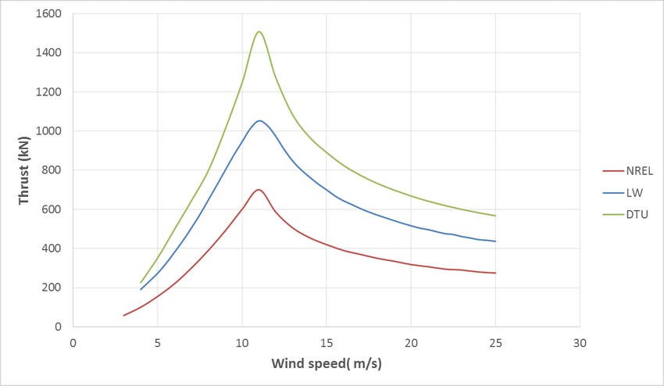

**Horizontal Axis Wind Turbines (HAWT):**

**- **Common Design:** HAWTs are the more traditional and prevalent type of wind turbine. They resemble windmills with their rotor blades arranged in a propeller-like fashion.**

**- **Rotor Placement:** In HAWTs, the main rotor shaft and the electrical generator are positioned at the top of a tall tower. To operate efficiently, HAWTs must always be oriented into the wind.**

**- **Wind Direction Control:** Smaller HAWTs rely on a basic wind vane to align themselves with the wind. In contrast, larger HAWTs employ advanced systems involving wind sensors and servo motors to precisely track the wind direction.**

**- **Efficiency:** HAWTs are known for their high efficiency. Their design ensures that their blades are continuously facing the wind, allowing for consistent power generation as the blades rotate.**

**- **Turbulence Considerations:** Due to the turbulence produced by the tower itself, HAWTs are generally placed upwind of the tower to ensure consistent and reliable performance.**

**\*\*Advantages of HAWT:\*\***

**- **Enhanced Wind Access:** The tall tower's placement allows HAWTs to tap into stronger winds at higher altitudes, especially in areas with wind shear. Wind shear causes a significant increase in wind speed for each additional ten meters in height.**

**- **High Efficiency:** HAWTs maintain their efficiency because their blades consistently move perpendicular to the wind, enabling continuous power generation throughout their rotation.**

**\*\*Disadvantages of HAWT:\*\***

**- **Tall Tower Construction:** The construction of large and massive towers is necessary to support heavy components such as blades, gearboxes, and generators. This construction aspect increases the overall cost of HAWTs.**

**- **Visibility and Landscape Impact:** The substantial height of HAWTs makes them visible across wide areas. As a result, they can disrupt the visual landscape and, in some cases, lead to local opposition to their installation.**

**- **Structural Fatigue:** Downwind HAWTs may experience structural fatigue and issues caused by turbulence when rotor blades pass through the wind shadow created by the tower.**

**- **Yaw Control:** To ensure that their blades consistently face the wind, HAWTs require complex yaw control mechanisms.**

**- **Braking in High Winds:** In strong wind conditions, HAWTs must employ braking or yawing mechanisms to prevent the turbine from spinning uncontrollably and potentially causing damage.**

**Vertical Axis Wind Turbines (VAWT):**

**- **Vertical Design:** VAWTs are characterized by their unique vertical rotor shaft, which allows them to capture wind from any direction, eliminating the need for precise alignment with the wind.**

**- **Component Placement:** In contrast to HAWTs, VAWTs place their critical components closer to the ground. This design simplifies maintenance and makes them suitable for rooftop installations.**

**- **Drag Force:** VAWTs generate drag when their blades rotate into the wind. This additional drag can affect their overall efficiency compared to HAWTs.**

**- **Rooftop Installation:** VAWTs are often mounted on buildings and structures. When positioned on rooftops, the wind speed can be significantly enhanced due to the building's redirection of wind over the roof. This increases their energy output.**

**- **Wind Turbulence and Vibration:** VAWTs positioned near the ground or other obstacles may encounter turbulent airflow, leading to vibration, noise, and potential wear on components.**

**\*\*Advantages of VAWT:\*\***

**- **No Yaw Mechanism Required:** VAWTs do not need complex yaw mechanisms to align with the wind's direction since they can capture wind from all directions.**

**- **Lower Height:** These turbines can be located closer to the ground, simplifying maintenance tasks and reducing construction costs.**

**- **Lower Wind Startup:** VAWTs have lower wind startup speeds, meaning they can efficiently generate power in regions with slower wind speeds.**

**\*\*Disadvantages of VAWT:\*\***

**- **Reduced Efficiency:** The unique vertical design of VAWTs can lead to lower efficiency due to added drag generated when the blades rotate into the wind.**

**- **Lower Wind Speeds:** Since VAWTs are closer to the ground, they typically experience slower wind speeds compared to HAWTs, which are positioned at greater heights.**

**- **Uncommon Design:** VAWTs are less common in the wind energy industry, which can lead to misconceptions and unrealistic claims, sometimes resulting in investment scams.**

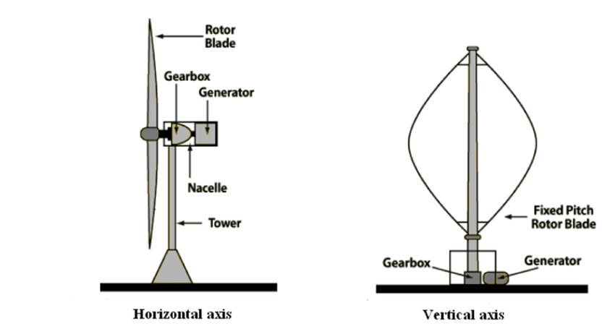

**Tip Speed Ratio (TSR) in Wind Turbines:**

**1. **Definition:** TSR is a crucial parameter for wind turbines, representing the ratio between the speed of the blade's tip and the actual wind speed it encounters.**

**2. **Efficiency Relationship:** TSR is directly related to a wind turbine's efficiency. The ideal TSR varies depending on the blade design, and it's a critical factor in optimizing energy conversion.**

**3. **Calculation of Tip Speed:** You can calculate the tip speed of a wind turbine blade using the formula TSR = wR, where:**

**- TSR (Tip Speed Ratio) is the ratio being calculated.**

**- w (ω) represents the rotational speed of the rotor in radians per second.**

**- R denotes the rotor radius in meters.**

**4. **Wind Speed Factor:** The wind speed at the height of the blade hub is a crucial factor that affects TSR. Higher wind speeds result in different TSR values.**

**5. **Impact on Blade Design:** Higher TSR values lead to increased noise levels, and they require blades to be stronger due to larger centrifugal forces. This is a vital consideration in blade design.**

**6. **Optimal TSR:** The optimal TSR varies for different wind turbines and is influenced by blade design and wind conditions. It's a key factor in maximizing energy capture.**

**7. **Balancing Efficiency and Noise:** Wind turbine designers must strike a balance between high TSR for efficiency and noise considerations to ensure optimal performance.**

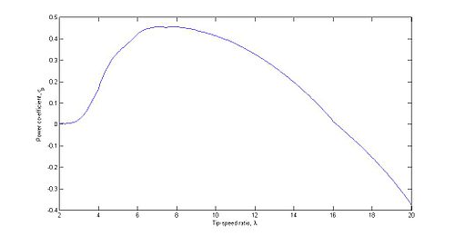

**Solidity in Wind Energy Conservation:**

**1. **Definition:** Solidity in wind energy conservation refers to the ratio of the total area covered by the wind turbine blades to the area swept by the rotor. It's an important factor in wind turbine design.**

**2. **Solidity Formula:** Solidity (σ) is calculated by dividing the total blade area (A) by the area swept by the rotor (A_swept):**

**- σ (Solidity) = A / A_swept**

**3. **Role in Efficiency:** Solidity impacts the aerodynamic efficiency of a wind turbine. It affects how the blades interact with the wind.**

**4. **Lower Solidity:** Wind turbines with lower solidity (less blade area compared to swept area) are more efficient at converting wind energy into electricity. They have less drag.**

**5. **Higher Solidity:** Wind turbines with higher solidity (more blade area compared to swept area) can capture more wind energy but may be less efficient due to increased drag.**

**6. **Blade Shape and Angle:** Solidity is influenced by the shape and angle of the blades. Designers optimize blade shapes to achieve the desired solidity for specific wind conditions.**

**7. **Blade Pitch Control:** Some modern wind turbines have blade pitch control mechanisms to adjust blade angles and solidity, optimizing performance in changing wind speeds.**

**8. **Solidity and Noise:** High solidity can increase noise due to the greater air resistance. Lower solidity turbines are often quieter.**

**9. **Environmental Impact:** The choice of solidity in wind turbine design can impact local communities in terms of noise pollution and efficiency in harnessing wind energy. Designers consider these factors in wind farm planning.**

**10. **Balancing Act:** Wind turbine designers aim to strike a balance between solidity, efficiency, and environmental factors to ensure sustainable and effective wind energy conservation.**

**Types of generators and power converters in WECS:**

**\*\*Direct Current (DC) Generators:\*\***

**- DC generators are primarily used in small-scale wind energy systems, such as those for residential or remote applications.**

**- They are relatively simple and cost-effective but are less efficient in capturing energy from variable wind speeds.**

**- Maintenance of DC generators involves regular checks and replacement of brushes and commutators.**

**- These generators may require additional equipment for converting DC power to AC for grid connection.**

**\*\*Alternating Current (AC) Synchronous Generators:\*\***

**- Permanent magnet synchronous generators (PMSGs) have gained popularity in recent years due to their high reliability and efficiency.**

**- Electrically excited synchronous generators (EESGs) are less common and often used in specialized applications.**

**- Synchronous generators require precise synchronization with the grid frequency, which can be challenging during varying wind conditions.**

**- These generators are generally more complex and expensive compared to other options.**

**\*\*AC Asynchronous Generators:\*\***

**- Fixed-speed induction generators (FSIGs) have been used historically but have limitations in adapting to changing wind speeds.**

**- Doubly-fed induction generators (DFIGs) are the preferred choice for modern wind turbines because of their adaptability and improved energy capture.**

**- Induction generators are reliable and cost-effective but may exhibit some disadvantages like limited speed control.**

**\*\*Switched Reluctance Generators:\*\***

**- Switched reluctance generators are known for their ruggedness and durability, making them suitable for harsh environments.**

**- They have relatively simple construction and can withstand high temperatures and adverse conditions.**

**- One drawback is their size and weight, which can be a disadvantage in applications where weight and size constraints are significant.**

**- These generators are less common in wind turbines but may find use in specific scenarios requiring high reliability.**

**The choice of generator type depends on factors such as project scale, budget, site conditions, and the need for efficiency and reliability. Modern wind turbines often use doubly-fed induction generators (DFIGs) or permanent magnet synchronous generators (PMSGs) to strike a balance between performance and cost-effectiveness.**

**Control schemes for power converters:**

**Control schemes for power converters in sustainable energy, such as wind turbines and solar systems, are essential for efficiently managing energy production and integration into the grid. Here are some key control schemes in easy language and points:**

**1. **Maximum Power Point Tracking (MPPT):\*\***

**- MPPT controllers are commonly used in solar panels and wind turbines to extract the maximum energy from variable sources.**

**- They continuously adjust the operating point of the generator to match the available energy source, optimizing power production.**

**2. **Voltage Regulation:\*\***

**- Voltage control is crucial to ensure a stable and consistent power supply from renewable sources.**

**- Controllers monitor and adjust the voltage output to match grid or load requirements, preventing voltage fluctuations.**

**3. **Grid Integration Control:\*\***

**- Power converters must synchronize with the grid's frequency and voltage for seamless integration.**

**- Grid-tied inverters ensure that the renewable energy source feeds power into the grid without disruptions.**

**4. **Anti-Islanding Protection:\*\***

**- This safety feature prevents renewable energy systems from operating independently when the grid goes down.**

**- If the grid disconnects, the control scheme ensures the system stops supplying power to protect utility workers.**

**5. **Fault Detection and Ride-Through Capability:\*\***

**- Control systems can detect faults or irregularities in the grid and respond accordingly.**

**- Ride-through capabilities allow the system to continue operating during temporary grid disturbances.**

**6. **Droop Control:\*\***

**- Often used in microgrids and distributed energy systems, droop control helps maintain a balance between multiple energy sources.**

**- When one source produces more power, the controller lowers its output to share the load evenly.**

**7. **Frequency Regulation:\*\***

**- Some power converters support frequency regulation by adjusting the output frequency to match grid requirements.**

**- This is critical in applications where precise frequency control is necessary.**

**8. **Energy Storage Management:\*\***

**- In systems with energy storage (e.g., batteries), control schemes manage charging and discharging to optimize energy use.**

**- Energy is stored during periods of excess production and discharged when needed.**

**9. **Remote Monitoring and Control:\*\***

**- Many sustainable energy systems use remote monitoring and control to allow operators to adjust settings, diagnose issues, and ensure optimal performance from a distance.**

**10. **Energy Forecasting and Predictive Control:\*\***

**- Advanced control systems use weather and energy production forecasts to proactively adapt to changing conditions.**

**- Predictive control optimizes energy production based on anticipated weather patterns.**

**These control schemes are crucial for maximizing the efficiency, reliability, and grid integration of sustainable energy systems while ensuring safe and stable operation.**

**Introduction to Grid Integration of Wind Energy Conversion Systems (WECS):**

**Grid integration of wind energy is essential for efficiently incorporating wind power into the electrical grid. Here's an easy-to-understand introduction in points:**

**1. **Harvesting Wind Energy:\*\***

**- Wind turbines capture the kinetic energy of the wind and convert it into electrical power.**

**- Wind energy is abundant and considered a clean, renewable energy source.**

**2. **Variable Nature of Wind:\*\***

**- Wind speeds fluctuate, and this variability poses a challenge for grid integration.**

**- Sometimes, the wind may blow strongly, while at other times, it may be calm.**

**3. **Grid Connection:\*\***

**- Wind turbines are connected to the electrical grid to supply the generated power to homes and businesses.**

**- Grid integration ensures a reliable energy supply, even when wind conditions change.**

**4. **Balancing Energy Supply and Demand:\*\***

**- The electrical grid must balance the supply of wind energy with the demand from consumers.**

**- Grid operators work to match the electricity produced by wind turbines with what people need.**

**5. **Intermittency and Forecasting:\*\***

**- Wind power is intermittent, meaning it's not always available when needed.**

**- Advanced forecasting techniques help predict wind patterns to prepare for fluctuations.**

**6. **Storage Solutions:\*\***

**- Energy storage systems, like batteries, can store excess wind power when production is high.**

**- Stored energy can be released during low-wind periods, ensuring a steady power supply.**

**7. **Grid-Friendly Operation:\*\***

**- Wind turbines are equipped with controls that allow grid operators to manage their output.**

**- Turbines can be remotely adjusted to align with the grid's needs.**

**8. **Transmission and Distribution:\*\***

**- Power generated by wind turbines is transmitted over high-voltage lines to substations.**

**- From there, it's distributed to homes and businesses via lower-voltage lines.**

**9. **Grid Stability and Reliability:\*\***

**- Grid integration should not compromise the stability and reliability of the electrical system.**

**- Grid operators use various technologies to maintain these essential qualities.**

**10. **Environmental Benefits:\*\***

**- Wind energy helps reduce greenhouse gas emissions and dependence on fossil fuels.**

**- It contributes to a cleaner and more sustainable energy future.**

**11. **Economic Impact:\*\***

**- Wind energy projects create jobs and stimulate local economies.**

**- They offer long-term cost savings compared to traditional energy sources.**

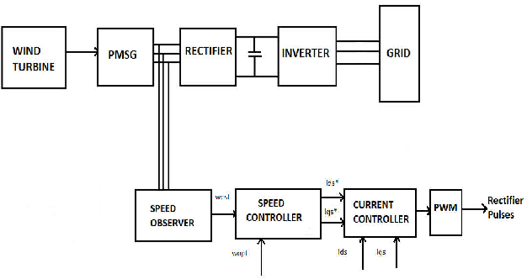

**Issues in grid integration:**

**1. **Intermittency of Renewable Sources:\*\***

**- Renewable sources like wind and solar are intermittent, and their energy production varies with weather and time of day.**

**2. **Matching Supply and Demand:\*\***

**- Grids must balance the irregular energy production of renewables with the continuous demand for electricity.**

**3. **Energy Storage Challenges:\*\***

**- Storing excess renewable energy for later use is crucial but can be expensive and technologically challenging.**

**4. **Aging Grid Infrastructure:\*\***

**- Many existing grids were not designed for large-scale renewable energy integration and require upgrades.**

**5. **Transmission Constraints:\*\***

**- Transmitting renewable energy from remote locations to urban areas can be limited by transmission capacity.**

**6. **Grid Stability:\*\***

**- Fluctuations in renewable energy supply can affect grid stability and reliability.**

**7. **Demand Response:\*\***

**- Encouraging consumers to adjust their electricity use based on renewable energy availability is a complex task.**

**8. **Regulatory and Policy Hurdles:\*\***

**- Regulations may not always support renewable energy integration, hindering progress.**

**9. **Grid Management Complexity:\*\***

**- Integrating diverse energy sources, including renewables, adds complexity to grid management.**

**10. **Cybersecurity Risks:\*\***

**- As grids become more connected, they are exposed to cybersecurity threats.**

**11. **Economic and Financial Barriers:\*\***

**- The initial costs of grid upgrades and integration can be significant.**

**12. **Environmental Concerns:\*\***

**- Environmental impacts of grid integration projects, such as large-scale transmission lines, are sometimes contentious.**

**13. **Community and Public Engagement:\*\***

**- Grid integration projects often require community support and may face opposition.**

**Addressing these issues involves a combination of technological innovation, smart grid management, policy adjustments, and public awareness to transition toward a more sustainable and reliable energy system.**